PRESS RELEASE

Quiet roller shutter motorisation, more creature comforts

Schlierbach, 24.01.2022 – Loud, clattering roller shutters considerably spoiled the peace and quiet normally enjoyed by the residents of a rented apartment in Soest, Germany. The solution: conversion to the quiet-as-a-whisper RolMotion drive series from elero. The result was so convincing that the owner, a construction company, set store by elero from the very outset in its next new construction project: all 40 sets of roller shutters on a multi-family house in North-Rhine Westphalia were fitted with RolMotion drives.

More creature comforts thanks to whisper mode
“The expectations of buyers and tenants have risen significantly in recent years, electric roller shutters are now the standard. People are specifically asking much more frequently about how loud shutters are.” This is something the elero regional manager Marcel Fellhölter has regularly heard from his trade customers in the past few years. Ultimately, noise levels have a tangible impact on the comfort of a home: automated roller shutters that you cannot help but notice when they suddenly start moving can rudely awaken young babies from their midday nap or be a disturbance in the middle of a video meeting when working from home, for example.

A solution to this problem is offered by elero with the RolMotion product series, which has a whisper mode. The opening and closing of blinds is scarcely audible in this slow operating mode: while the standard mode is already quiet with a noise level of just 45 decibels, in its slow mode RolMotion produces a mere 35 decibels – comparable with the sound of leaves rustling. RolMotion 868 always moves roller shutters in whisper mode with automated commands; manually this feature can be activated at the push of a button. In standard mode with the usual running speed the profiles are brought to a gentle stop before the end position. This protects the roller shutters and extends the service life of the whole system.

Value appreciation thanks to high-quality drives
The specialist firm Stiens Baumontagen in Erwitte-Horn, near Soest, has many years of experience in the refurbishment and renovation of old buildings and therefore recommended RolMotion for the conversion of the rented apartment. The benefits were tangible: the noise emissions indoors amounted to a mere 26 decibels. “The result was not only pleasing for the residents, but also for the construction company. With new construction projects it intends to use elero RolMotion from the very outset in the future. Thus ensuring there is not the possibility of costs for later remediation of any defects, and the up-market fittings increase the value of the property,” says Marcel Fellhölter. The first new construction project with eleven residential units has already been fitted with RolMotion drives.

In addition to optimised running characteristics, RolMotion convinces with the proven elero drive technology. Just like the entire RolTop series, RolMotion has obstacle and blockage recognition, as well as Soft Start and Soft Stop. This means that the drives are reliable and have a long service life while protecting roller shutters. elero underlines this with its seven-year material guarantee for RolMotion. The product series is available as a wired version or with radio technology. In addition elero has developed an “EnOcean” version. The installation and adjustment of the RolMotion drives is, as ever, simple and swift. The company from the state of Baden-Wuerttemberg – which specialises in roller shutters and sun protection within Italy’s Nice Group – has already been honoured with the R+T 2021 Innovation Prize for its intelligent roller shutter drive.

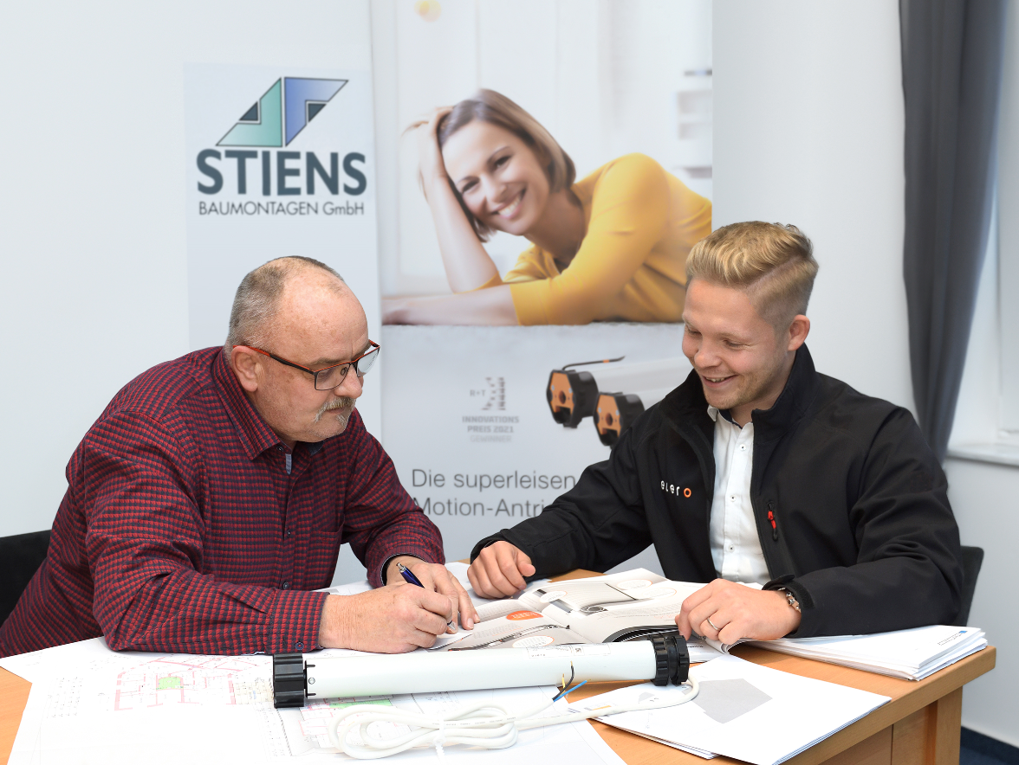

Photo 1
Master craftsman Joachim Seise from Stiens Baumontagen (left) and elero regional manager Marcel Fellhölter (right) plan the conversion of loud motors in a rented apartment. The solution is RolMotion – much to the pleasure of the residents. (Photo: elero)

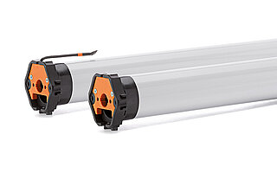
Photo 2
Quiet motorisation with RolMotion is available with radio technology or as a wired solution. The D+ version with Plug+Play and an EnOcean version supplement the offering from the drive manufacturer. (Photo: elero)

Photo 3
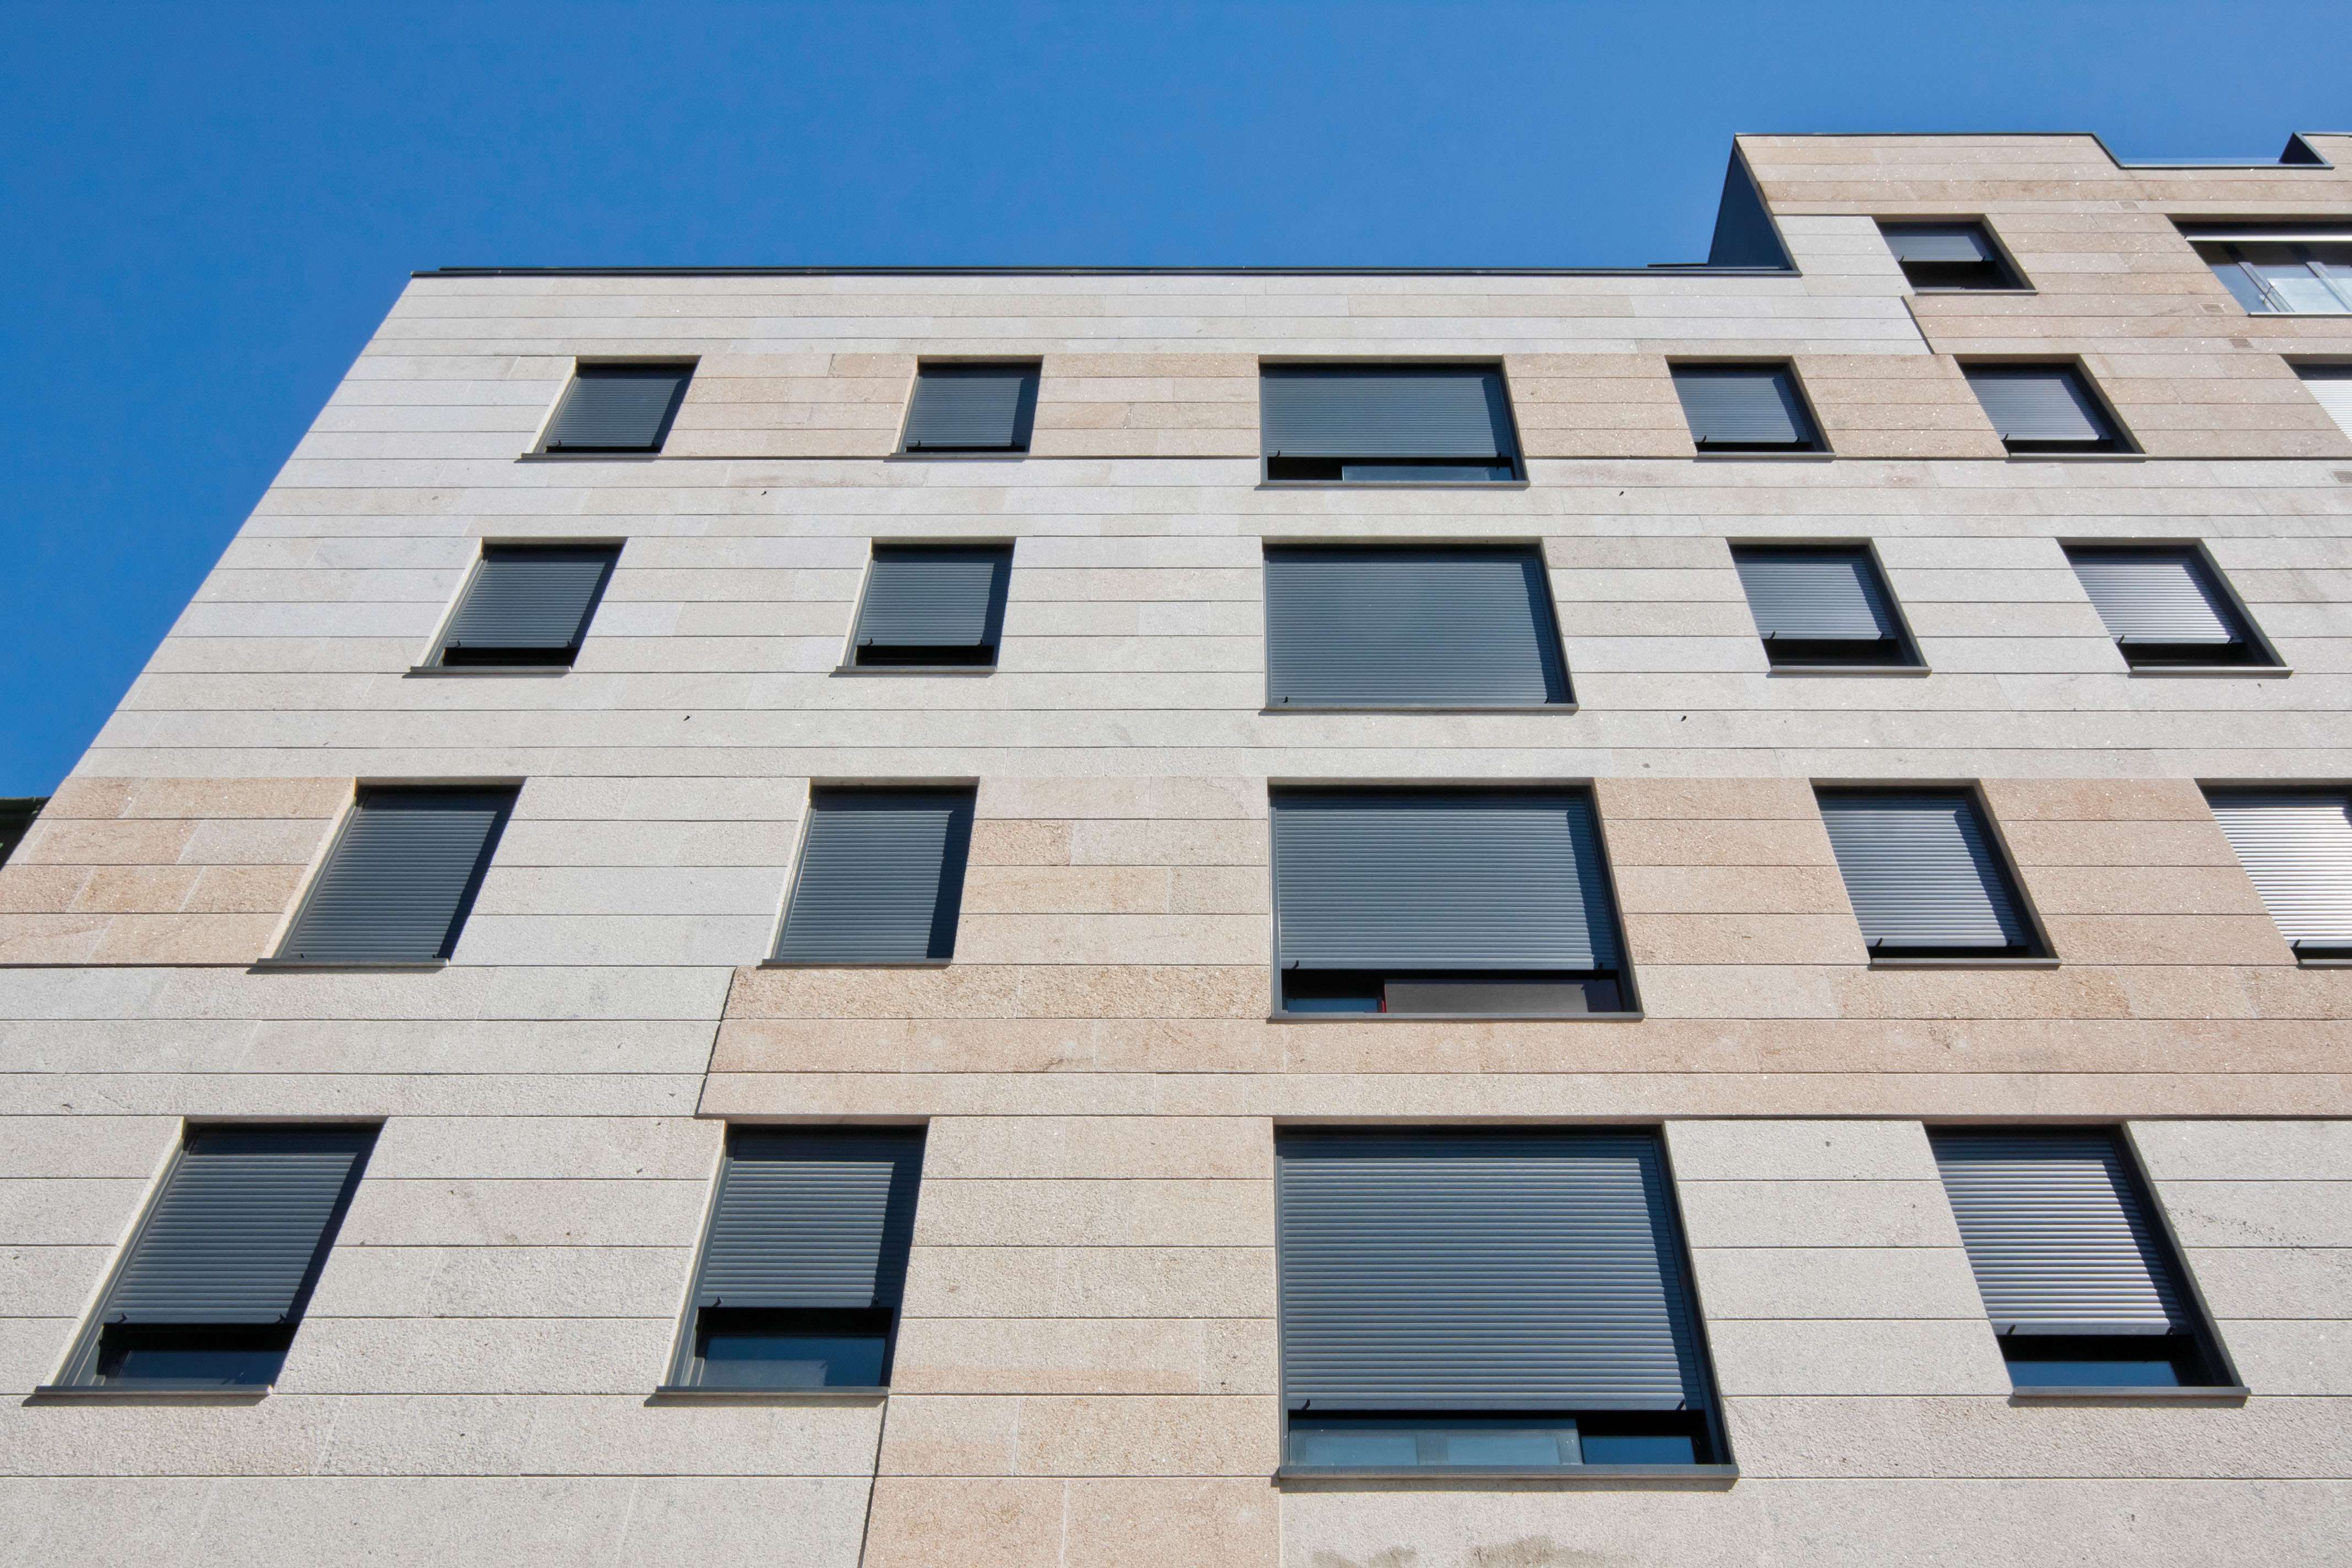
Quiet motorisation increases the value of a property, and thanks to its whisper mode never disturbs residents. (Photo: Nice)

elero, with its headquarters in Schlierbach near Stuttgart, is one of the largest global manufacturers of electrical drives and control systems for roller shutters and sun protection systems. A second division of the company is concerned with the development and manufacture of electric linear actuators. The drive manufacturer is a wholly-owned subsidiary and independent premium brand for screen automation solutions in the Italian Nice Group, a multi-nationally active supplier of products in the sectors of home automation, home security and smart home.
www.elero.com

Founded in the early 1990s, Nice is a world leader in the Smart Home, Home Security and Home and Building Automation markets. It has a comprehensive offering of integrated solutions for the automation of gates, garage doors, solar protection, parking systems, wireless alarm systems and home security in residential, commercial and industrial buildings. Nice has launched a strategic plan to expand and broaden its portfolio of products and connected platforms. It offers a wide range of customizable and easy-to-use options for the end user and seeks to strengthen and expand in markets with high growth potential, improving and renewing its brand to compete in new market segments. Nice exports its products, which combine technological innovation and design, to more than 100 countries.
For more information visit: www.niceforyou.com.
LinkedIn I Facebook I Twitter I Instagram
#nice #niceforyou #smarthome #homeautomation #homesecurity

Contact  Wächter PR  Tanja Gottwald  t.gottwald@waechter-waechter.de  +49 (0)89/74 72 42-75 | elero  Inge Rappold  Inge.Rappold@elero.de  +49 7021 9539-319

