PRESS RELEASE

Learning in optimal light conditions
The well-lit new Carl-von-Ossietzky Comprehensive School building in Cologne relies on venetian blind drives with an SMI interface from elero for intelligent building automation

Cologne/Schlierbach, 26th July 2021 - With generous glazing, many views into and across the surrounding greenery, a sustainable energy concept and a modern glass-fibre concrete façade, the Carl-von-Ossietzky Comprehensive School in Cologne-Longerich, which was completed in 2020, enables about 1,000 pupils and teaching staff to learn and teach in a green environment. 415 external venetian blinds motorised with JA Comfort SMI drives from elero provide optimum lighting conditions and summer heat protection.

The location of the Carl-von-Ossietzky Comprehensive School is unusual for a school. It is situated in a landscape conservation area. In addition to the pedagogical concept, this special feature was a key factor of the winning design by architects Ackermann + Renner from Berlin, which was developed over the course of a two-phase interdisciplinary competition. The location of the site required sensitive handling of the old tree population and a spatial concept that responds appropriately to the location and its users.

School in the park
Located on premises that were previously occupied by a school building and are surrounded by trees, the new building is divided into three rectangular sections. They accommodate the technical and senior classrooms, the lower and middle school classrooms and a triple-use gymnasium. Due to its shape and spatial organisation, the building merges with the landscape and becomes a school in the park.

The facade has a modern appearance while also harmonising with the surroundings. The enclosed areas were designed as a curtain-style rear-ventilated façade with glass-fibre concrete laths in silver-grey, which create a vibrant structure thanks to three different surfaces. Glazed strips reflect the foliage of the trees and green panels pick up the colour of the surrounding landscape. A colourful interplay of light and shadow is created on the floors and walls, depending on the lighting situation.

Top-quality privacy screen with glare protection
The feeling of light and openness also extends to the interior of the school. All rooms benefit from the generous glazing. There are no dark corridors here. To optimally control the daylight as required, 415 external venetian blinds from Eurosun have been installed. The aluminium louvres direct the light very cleverly and provide visual comfort in the classroom. Students and teachers are protected from the disturbing glare of direct sunlight, but can still enjoy the greenery.

The motorisation of the external venetian blinds is implemented with JA Comfort SMI drives from the Baden-Württemberg manufacturer elero. While the upward and downward movement of the blinds is very fast at 26 revolutions per minute, the slats are turned extremely slowly at six revolutions per minute to allow the user to make very precise adjustments – as an efficient privacy screen with glare protection that allows the finest gradations when controlling the amount of incoming daylight. Thanks to the noiseless soft brake, the end positions are approached quietly without "clacking noises".

Economical lighting comfort thanks to SMI
The feedback-capable venetian blind drive with electronic limit stop and integrated SMI interface can communicate with controllers or with a BUS system (e.g. KNX, LON) by means of corresponding actuators. At the Carl-von-Ossietzky Comprehensive School, the drives are integrated into BUS systems and are automatically controlled by light and wind sensors. The levels of shade in each room can be adjusted manually if necessary. "The SMI interface ensures easier installation and therefore cost savings, especially for large projects. By connecting drives in parallel and using common cable types, up to 16 electronic drives can be controlled with a single BUS system", says Peter Schmidt, Key Account Manager at elero.

Easy maintenance
In addition, SMI drives by elero offer additional functions that are not possible using conventional drives. These include, for instance, commands for precise approach of intermediate positions or sensing of current position. Cyclical reference runs ensure that the external venetian blinds are optimally positioned even over a long period of time and provide a uniform appearance. The drives are very precise and indicate the operating status to the actuator or to a PC connected for service purposes. If necessary, a bootloader can be used to replace the drive software
without removing the drive.

Saving energy
In addition to the light comfort factor, the external shading also contributes to the energy efficiency of the school building by providing summer heat insulation. The comprehensive school has a sustainable energy concept. The energy, which is generated by a groundwater heat pump system, can heat the entire building and produce hot water for the showers in the gymnasium. Some sections of the roofs are extensively greened, while others are covered with a photovoltaic system for the school's own power supply.

Picture material:

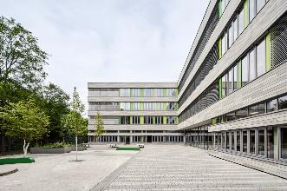 | Fig. 1: Exterior view  415 external venetian blinds from Eurosun are motorised by SMI drives from elero to provide lighting comfort and energy efficiency.  (Copyright: Annika Feuss/elero GmbH)
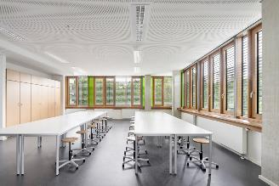 | Fig. 2: Classroom  Glare protection with the best possible view: intelligent control of the sun protection system ensures a high level of lighting comfort.  (Copyright: Annika Feuss/elero GmbH)
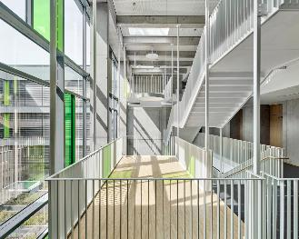 | Fig. 3: Gallery  Generous glazing and panels in shades of green create an invigorating interplay of light and shade.  (Copyright: Annika Feuss/elero GmbH)
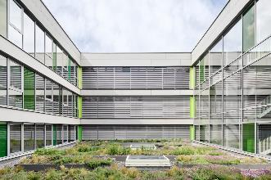 | Fig. 4: Green roof  The JA Comfort SMI drives are integrated into BUS systems and are automatically controlled by light and wind sensors.  (Copyright: Annika Feuss/elero GmbH)
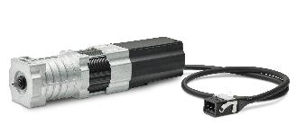 | Fig. 5: Product image  JA Comfort SMI - Venetian blind drive with electronic limit stop and integrated SMI interface for connection to BUS systems.  (Copyright: elero GmbH)

Elero GmbH
Elero, with its headquarters in Schlierbach near Stuttgart, is one of the largest global manufacturers of electrical drives and control systems for roller shutters and sun protection systems. A second division of the company is concerned with the development and manufacture of electric linear actuators. The drive manufacturer is a wholly-owned subsidiary and independent premium brand for screen automation solutions in the Italian Nice Group, a multi-nationally active supplier of products in the sectors of home automation, home security and smart home. www.elero.com

