PRESS RELEASE

Nice and elero announce sustainable change
Oderzo/Schlierbach, 29th July 2021 – The issue of sustainability is to be firmly established as a fundamental pillar in the business strategy of Nice, the Italian multinational home automation, home security and smart home company. The company's stated goal is to achieve a paradigm shift in corporate development at a global level. The Baden-Württemberg-based company elero, a 100% subsidiary of Nice and a specialist within the group for roller shutters and sun protection, is also part of the sustainability initiative. To achieve their ambitious goals, Nice are relying on the expertise of eAmbiente, an external consultancy specialising in management solutions that are sustainable from an environmental, social and financial perspective.
Overall strategy instead of individual measures
"From Nice's perspective, the issue of sustainability and the business strategy must go hand in hand," says Marco Bianchet, Quality & Sustainability Global Director at Nice, who is responsible for the project. "We have been implementing similar measures for some time, but from now on we want to approach corporate sustainability in a more organic and structured way. Our goal is to leverage Nice's innovative technologies to become the sustainable market leader in home automation, smart home and home security." Through their actions and decisions, Nice aim to set an example with this meaningful path and inspire all stakeholders in their supply chain to follow suit.
Carbon footprint put to the test
As a first step, the organisation's carbon footprint will be measured in 2021, i.e. the greenhouse gas emissions generated by its production activities, expressed in CO2 equivalents. On this basis, Nice's processes and products will be evaluated to reduce their effects on health, water, atmosphere and soil. The goal is to bring CO2 emissions down to zero or reduce them significantly. In doing so, the company intends to align itself with the standards of the United Nations Paris Climate Agreement. A sustainability report will be prepared in parallel. This comprehensive analysis of the effects of Nice's activities on their immediate environment and the environment at a global level is intended to serve as a guideline for defining the company's sustainable strategy.

Ambassadors for fundamental change
In addition, ambassadors for the topic will be recruited within the company and a sustainability committee will be set up to work both strategically and operationally. These teams will define in detail the vision, mission and goals on the path to greater sustainability and establish time frames and evaluation criteria for implementing the measures. "The path towards sustainability requires a fundamental cultural change that will affect the group at an international level and every plant will be involved. It is an ambitious but beautiful challenge that we hope will inspire others to do the same," says Roberto Griffa, CEO of Nice and main promoter of the project. Gabriella Chiellino, Founder and President of eAmbiente adds, "Nice's innovation will be instrumental in working with our experts to create a global sustainability plan and help reduce our climate impact."
Picture material: (photos: Nice)
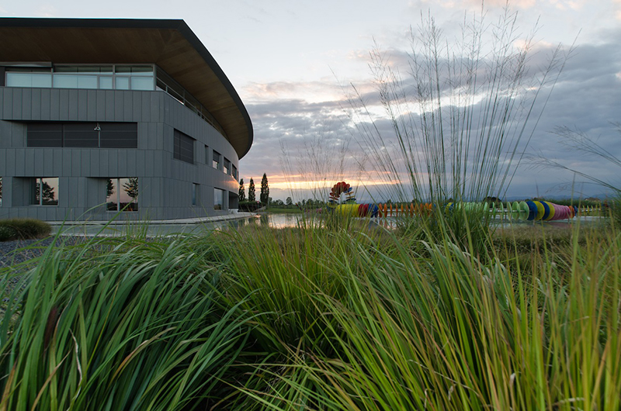
Fig. 1: Nice wants to make sustainability a cornerstone of its business strategy. (Copyright: Nice)
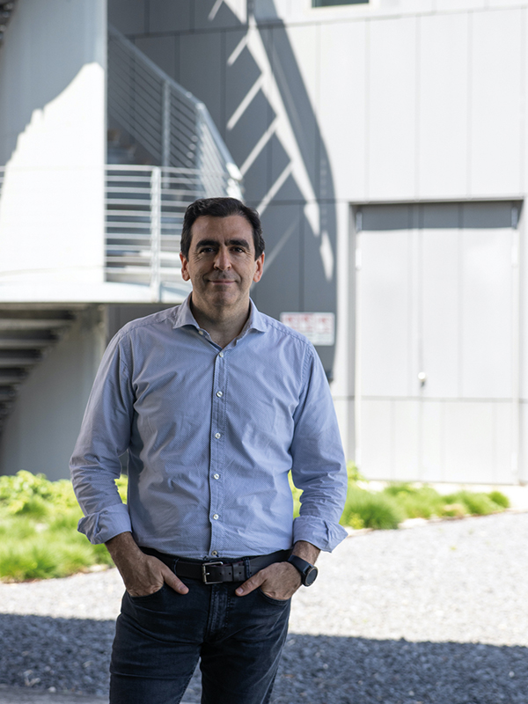
Fig. 2: Roberto Griffa, CEO of Nice (Copyright: Nice)

About Nice and elero
An Italian multinational company based in Oderzo (TV) with a strong international focus, Nice is an international leader in Home Automation, Smart Home and Home Security with the aim of combining functionality and design to simplify people's daily actions. Nice is synonymous with technology and excellence. Its solutions are used in public and private spaces all over the world, including airports and prestigious locations.
FIBARO is a global brand, based on the technology of the Internet of Things, which offers solutions for smart home automation. The products are designed and manufactured entirely in Poland, with the aim of enriching people's lives with modern solutions that provide a comfortable, friendly and safe home environment.
A specialist in the sun protection solutions of the Nice brand, elero is one of the world's leading manufacturers of electric drives and control units made in Germany. A second business unit is focused on the development and production of electric linear actuators.
www.niceforyou.com
www.elero.de

