Press release
Nice announces double-digit million investment plan for its Sun Shading Solutions business unit
Nice announces double-digit million investment plan for its Sun Shading Solutions business unit

Oderzo/Schlierbach, 09th September 2021 – Nice is planning to further increase the production capacity of their fledgling business unit Sun Shading Solutions with extensive investments over the next three years. "We are focusing our activities on our customers. The investments will help us to deliver increasing quantities in a timely manner in order to meet the requirements of our market partners at all times", explains Enzo Viola, CEO of elero and the Sun Shading Solutions business unit.

With elero's expertise in this sector and Nice's strength as a global player, the business unit, which is responsible for all the group's sun protection activities, is ideally positioned. The product range includes roller shutters, textile sun protection, venetian blind and façade applications with the Nice and elero brands. The dynamic market development and the acquisition of new customers contributed to rapid growth in the current year, which is expected to generate sales of 150 million euros in 2021.

Long-term strategy
However, global difficulties in the supply of raw materials and related price increases have become a challenge. Furthermore, the business unit is pursuing a long-term strategy based on a three-pillar approach to enable customer-oriented delivery times in the face of increasing demand.

The production capacity of elero tubular motors at the Schlierbach plant will be doubled as early as November 2021.
In addition, the business unit's competencies are being used to verticalise production. Important components are manufactured in-house in order to respond more efficiently and independently to the demands of the global market in the coming years.

Expansion of outbound logistics
In a third step, Nice and elero will get closer to the customer by expanding outbound logistics. Even greater logistics expertise and geographical proximity to customers in the most important markets play a decisive role here.
"We are confident that, with elero's years of experience in the sun shading sector and Nice's global strength, our mid and long term business plan is on a good footing. The planned investments are particularly significant from a strategic point of view. They will help to ensure further development while also strengthening our market position at an international level even faster", says Roberto Griffa, CEO of Nice.

The business unit was founded in January 2021 and is located at both plants: at Nice's headquarters in Oderzo, Italy, and at elero in Schlierbach, Baden-Württemberg. As a subsidiary of Nice, this traditional manufacturer specialises in drive and control solutions concerning privacy and sun protection.

Picture material
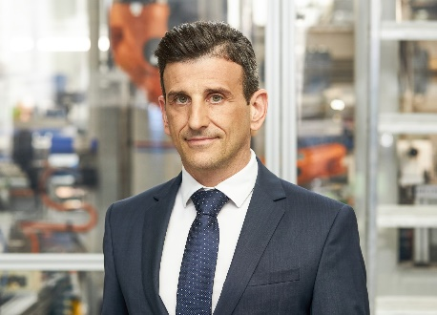 | Image 1:  For Enzo Viola, CEO of elero and the Sun Shading Solutions business unit, the focus of activities is on customers and the ability to deliver products. (Image: Nice)
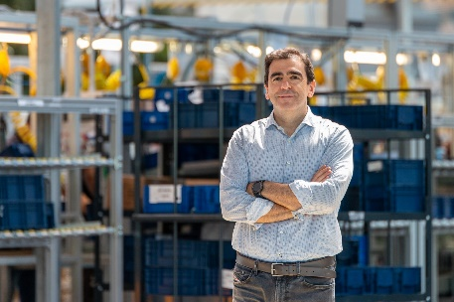 | Image 2:  Roberto Griffa, CEO of Nice, is sure that the investments will help to ensure further development and at the same time strengthen the market position on an international level even faster. (Image: Nice)
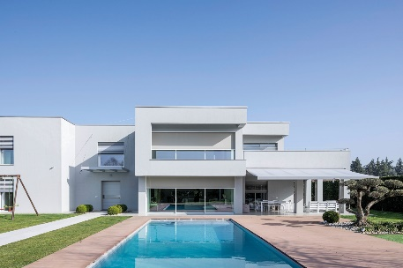 | Image 3:  For Enzo Viola, CEO of elero and the Sun Shading Solutions business unit, the focus of activities is on customers and the ability to deliver products. (Image: Nice)

Nice
An Italian multinational company based in Oderzo (TV) with a strong international focus, Nice is an international leader in Home Automation, Smart Home and Home Security with the aim of combining functionality and design to simplify people's daily actions. Nice is synonymous with technology and excellence. Its solutions are used in public and private spaces all over the world, including airports and prestigious locations.. Thanks to its founder and current Chairman, Lauro Buoro, and the 2.300 professionals who work every day to achieve the company's objectives, the Nice group distributes its products in over 100 countries around the world, with 24 branches on 5 continents, 14 production units and 13 research and development centres.
www.niceforyou.com

elero
Elero, with its headquarters in Schlierbach near Stuttgart, is one of the largest global manufacturers of electrical drives and control systems for roller shutters and sun protection systems. A second division of the company is concerned with the development and manufacture of electric linear actuators. The drive manufacturer is a wholly-owned subsidiary and independent premium brand for screen automation solutions in the Italian Nice Group, a multi-nationally active supplier of products in the sectors of home automation, home security and smart home.
www.elero.com

Contacts

Contact Italy |  | Contact Germany
EY |  | Talk of Town. Wächter & Wächter
Maria Elena Badini  Ph. +39 331 177 0516  maria.elena.badini@it.ey.com | Susanna Tagliento  Ph. +39 331 636 7029  susanna.tagliento@it.ey.com | Juliane Speigl  Ph. +49 89 747 242 26  j.speigl@waechter-waechter.de

