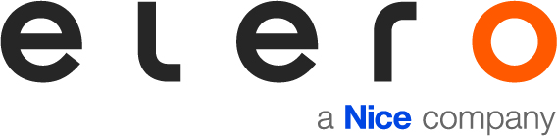

PRESS RELEASE

Nice: New Smart Home Business Unit concentrates expertise
Oderzo/Schlierbach, 7 July 2021 - Germany's households are becoming increasingly smart in terms of equipment and networking. The multinational Italian company Nice is responding to this trend and positioning itself even more strongly in this area with its new "Smart Home" business unit. Most recently, at the beginning of the year, the company pushed ahead with its growth strategy in the sun protection sector with the new "Sun Shading Solutions" business unit under the leadership of elero's managing director Enzo Viola.
The new "Smart Home" business unit is pursuing the goal of integrating Nice and elero solutions in order to network entire houses and focus on the residents and their individual requirements. The team is led by Adam Krużyński, CEO of Nice Poland and FIBARO, the specialist smart home company under the umbrella of Nice. "Our goal is to create a solution that is tailored to people's lifestyles and makes it possible to create individual scenarios for a smart, cosy and comfortable living space - for the whole family from morning to night," says Krużyński.
He also sees the smart home market as a strategic challenge and opportunity: "Everyone will be able to change the way they live and interact with their homes, making everyday life easier and more functional. This makes it all the more important for us to provide solutions that are increasingly connected, easy to implement and user friendly."
Juan Pablo Boz, who has recently joined Nice as Head of Marketing and has many years of experience in the smart home sector, cites the Yubii Home all-in-one gateway as an example. The big advantage of the new hub is its versatility. It is not only a hub for Nice, Fibaro and elero technologies, but can also integrate devices from other manufacturers thanks to its compatibility with Z-Wave® and WiFi™ protocols. Yubii Home is compatible with more than 3,000 devices from other brands and allows end users to manage their entire smart home with the voice assistants Amazon Alexa, Google Assistant and Siri. In addition, the gateway can support an IP camera and up to five devices by means of app plug-ins. In Germany, Yubii Home will be distributed by elero at the end of the year.

Picture material: (photos: Nice)
Fig. 1: Adam Krużyński, CEO of Nice Poland and FIBARO, is the head of the new Smart Home business unit.
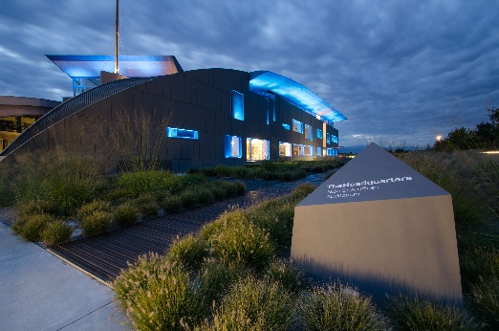
Fig. 2: Nice is positioning itself even more strongly with its new "Smart Home" business unit.
Fig. 3: With smart solutions like the Yubii Home all-in-one gateway, Nice wants to make smart home experiences even easier and more customer-specific.

About Nice and elero
An Italian multinational company based in Oderzo (TV) with a strong international focus, Nice is an international leader in Home Automation, Smart Home and Home Security with the aim of combining functionality and design to simplify people's daily actions. Nice is synonymous with technology and excellence. Its solutions are used in public and private spaces all over the world, including airports and prestigious locations.
FIBARO is a global brand, based on the technology of the Internet of Things, which offers solutions for smart home automation. The products are designed and manufactured entirely in Poland, with the aim of enriching people's lives with modern solutions that provide a comfortable, friendly and safe home environment.
A specialist in the sun protection solutions of the Nice brand, elero is one of the world's leading manufacturers of electric drives and control units made in Germany. A second business unit is focused on the development and production of electric linear actuators.
www.niceforyou.com
www.elero.de

