PRESS RELEASE
R+T 2018

Ideal entry-level smart home solution
elero presents open and modular home automation system

Schlierbach/Stuttgart – elero is launching its new home automation solution, Centero Home, which delivers all the functions required to turn a simple house into a smart home. The system presented at R+T 2018 covers all the functions relating to roller shutter and sun protection system control. In addition, building technology and security components from other manufacturers can be integrated, as can third-party lifestyle products. Thus Centero Home makes a major contribution to enhancing the quality of life for users in terms of comfort, security and energy efficiency.

From sun protection system control to the smart home
Smart controls are establishing themselves in the home environment in ever greater numbers. In this respect roller shutters and sun protection systems are right at the top of every construction client’s wish list. Centero Home is, therefore, the ideal entry-level solution for the creation of a smart home. The system communicates using radio (433 MHz and 868 MHz), infrared or IP, is easy and intuitive to operate, and right from the start it delivers bags of comfort. Marketed through the specialist trade, it is easy to set up, and can be combined with elero radio drives, receivers and sensors, and also with building technology products from other providers.

Open system with a large number of interfaces
Users can remotely operate, regulate and manage connected devices via a smartphone or tablet based on iOS and Android – while out and about for the day or from within their own four walls. Centero Home can be used in a cloud environment or locally over Wi-Fi. In addition to motorised sun protection, it is possible to integrate Philipps Hue lights, motion detectors, smoke alarms, window contacts, radiator thermostats and temperature sensors as standard. A weather service with a forecast is already integrated – ensuring the user is always kept up-to-the-minute.

Upgrade possibilities without any need for system change
With the in-app upgrade to Centero Home Plus end-users can unlock additional functions without the need for a hardware upgrade. Sonos home sound systems, Doorbird video door stations, Osram Lightify, Netatmo weather stations and other smart home applications can all be networked. And not least of all: Centero Home Plus may be controlled using Amazon Alexa.

Zeichen Fließtext (ohne Abbinder, inkl. Leerzeichen): 2.201

About elero
elero, domiciled in Schlierbach near Stuttgart, is one of the world’s largest manufacturers of electric motors and controls for roller shutters, sun protection systems and rolling doors. A second business division develops and produces electric linear actuators. With 430 employees worldwide the company generated sales of 75 million euros in 2016. The drive manufacturer is a wholly-owned subsidiary and independent premium brand for screen automation solutions within the Italian group of companies The Nice Group.

Photos:

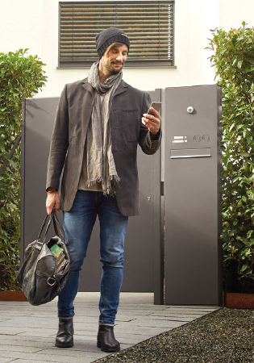
Sun protection systems can be controlled with ease via smartphone using the home automation solution Centero Home.
(Photo: elero GmbH)

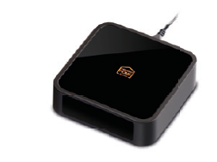
Centero Home can be combined with other smart home products via interfaces such as radio or KNX. It can be used both in a cloud environment and locally over Wi-Fi. (Photo: elero GmbH)

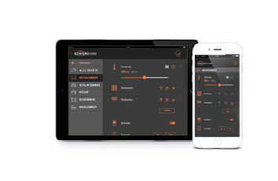
The system has its own app, with versions available for iOS and Android devices. Control via Amazon Alexa is possible after an in-app upgrade to Centero Home Plus. (Photo: elero GmbH)

The text and photos to this press release are available for download under presseportal.brandrevier.com/elero.

Contact:  Inge Rappold  Tel: +49 7021 9539-100  Mail: inge.rappold@elero.de  elero GmbH  Maybachstraße 30  73278 Schlierbach | Editorial office:  Tobias Nazemi  Tel: +49 201 8742 9311  Mail: nazemi@brandrevier.com  Brandrevier GmbH  Gemarkenstr. 138a  45147 Essen

